Introduction
The Camera Club is now beginning to adopt hybrid meeting where some of our members are present at the club meeting room and others are joining the meeting via Zoom. Using Zoom has also allowed the club to use Presenters who are not local to our area and cannot attend in person and this is a policy that is likely to continue. Meetings where the Presenter is present will also be broadcast to members via Zoom. This document will define the hardware required and how to set it up and also the use of zoom and equipment for both scenarios. Scenario 1 – Remote Presenter, Scenario 2 – Local Presenter
Requirements to maintain social distancing have resulted in the reduction in the maximum number of people that our Club room can accommodate for meetings of the Club. Also, the Club may wish to reduce the number of attendees at a meeting to meet our own social distancing requirements. As a consequence, it could become necessary to introduce a booking system if the number of members wishing to attend exceeds the maximum allowed in the room used. In order to make this manageable and fair we have looked at a number of alternatives and have concluded that the following will work best.

Eventbrite
Eventbrite is an international event ticketing system that allow organizers to promote events, sell tickets and manage attendance. Ordinarily Eventbrite charges a service fee for every paid ticket or add-on sold but if tickets are free, we don't pay any fees. To manage the number of members attending an event this is therefore a free service. We can create an event and advertise free tickets only to our members. They will be able to apply for tickets and when maximum have been allocated can opt to join a waiting list. As organiser on the day of the meeting we can download a list of attendees and use that to manage attendance.
The web site is accessed at https://www.eventbrite.co.uk/.

Process
The process to set up and manage a meeting is straightforward. An account in Eventbrite has been set up with user name <camera.mbcc@gmail.com> to manage events effectively.
Step 1 – Create Event
Click ‘create event’ button. This will take you to the Basic Info page.
Enter the event title & organiser
Type: <Meeting or Networking Event>
Category: <Hobbies & Special Interest>
Sub-category: <photography>
Enter the location & date and time: <save and continue>
Step 2 – Add Description
Add a short description about the meeting: <save and continue>
Step 3 – Create Tickets
Set tickets as: <Free>
Name: <General Admission>
Available Quantity. Set maximum number of attendees: <25>
When are tickets available? <Set a date and time>
<Save>

Step 4 – Check Tickets <Next>

Step 5 -Publish Your Event
Who can see you event: <Private>
Choose your audience <Anyone with the link>
Will the event ever be public <No, keep it private>
<Publish>

Step 6 – Share with friends
Copy event URL and email to all Club Members

Once above is complete the organiser can log in to the Manage my Events page and look at the Event Dashboard and see how many tickets have been sold and a waitlist also be enabled if required. An attendee list can be reviewed and downloaded as a PDF to be used at the meeting

Hardware
Following is a list of recommended hardware.
Club laptop Computer running Windows 10/11
- Laptop with Zoom (https://zoom.us)
- Iriun app loaded (https://iriun.com)
- FastStone Image Viewer
- DiCentra
- PowerPoint Viewer
Kensington Wireless USB Presentation Clicker with Red Laser Pointer
Digital Projector - Canon XEED WUX450
Bluetooth external speaker – Bose SoundLink Mini ll
Webcam – Logitech C920 (This is used in addition to camera inbuilt to laptop)
Smartphone with Iriun app loaded
Tripods or suitable stands to mount Cameras on.
Active USB Cable (needed to allow webcam to be placed away from laptop)
Radio Mike – fifine K031B
Wifi Hub – Vodafone RG219 Mobile Wi-Fi hotspot

Wifi Set up
If the room does not have Wi-Fi or an ethernet connection we will have to use a 4G Mobile Wi-Fi hotspot. The Vodafone RG219 allow up to 10 devices to connect at one time. The device had 15GB data pre-loaded on Pay as you go. This should be monitored via the Vodafone login on their website and topped up as necessary. Note data pack is valid for 90 days.

External Speaker Set up
Ensure Bluetooth is enabled on laptop
Power on Bose speaker & Press Bluetooth button. Speaker should connect to laptop and spell out device name <camera club>
Adjust volume using controls on Bose speaker.
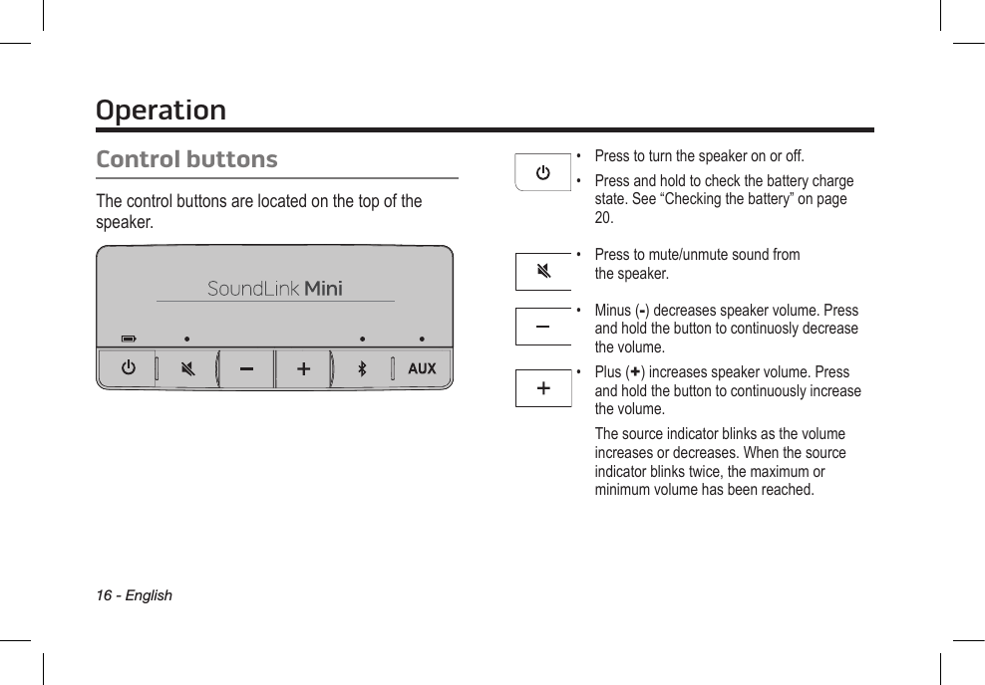

External Camera Set up
Connect Webcam to USB on laptop via the active USB cable. For Scenario 1 - The camera should be mounted on a stand and can face the audience so members viewing at home can see the attendees. For Scenario 2 - The camera should be mounted on a stand and can face either the audience or the Presenter so members viewing at home can see the attendees or the Presenter.
If an additional camera is required connect Smartphone using Iriun app. Both phone and the laptop have to be on the same wifi system.
When running the meeting via Zoom the host can switch between the available cameras. On the main Zoom screen, the controls for the cameras are on the bottom LHS. Press ^ adjacent to Stop Video to select camera or use short cut below.
Select a Camera (Alt+N to switch)
WebCam - HD Pro Webcam C920
Smartphone – Iriun Webcam
Laptop Camera - Chicony USB2.0 Camera

External Microphone Set up
Connect the FiFine receiver to a USB port on the laptop. The receiver light will remain blue after it pairs with the transmitter.
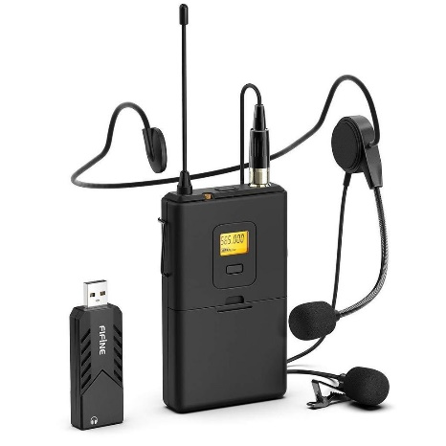
There are two microphones.
- Headset Microphone
- Lavalier (lapel) Microphone
Connect the chosen mic to the Body-Pack Transmitter.
Press and hold the on/off button until you see the channel number.

Select a Microphone
When running the meeting via Zoom the host can switch between the available microphones. On the main Zoom screen, the controls for the microphones are on the bottom LHS. Press ^ adjacent to Mute and Select a Microphone
Microphone on Webcam - HD Pro Webcam C920
Microphone on laptop - Realtek High Definition Audio
Wireless Microphone - USB PnP Audio Device

Projector set up
Connect the projector using the HDMI cable between the laptop and the HDMI port on the projector. The laptop needs to be set up for Multiple Displays. It will auto detect the projector to be used for the following display options.
Set up dual monitors on Windows
To change what shows on our displays, press Windows logo key + P. Here's what you can choose.
If you want to | Choose
See things on laptop display only. | PC screen only
See the same thing on all displays. (i.e. Projector Image too) | Duplicate
See your desktop across multiple screens. When you have displays extended,  you can move items between the laptop and the projected display. | Extend
See everything on the projected display only. | Second screen only

The option which should be used for meetings is ‘Extend’. This will allow the presentation to be projected (Screen 2) and viewed at home and also allow the host to monitor and manage the meeting from the laptop’s screen (Screen 1). How this is managed throughout the meeting is detailed in the meeting processes below.

Zoom Meetings

General
Camera Club meetings have been set up in Zoom as recurring meetings. That is the meeting ID remains the same for every meeting. To host a meeting, you need to download the Zoom app to your PC, already loaded onto the Club Laptop, and log into the Club Account. You can copy the invitation for the meeting and forward via email to the lecturer and the Club members. There are how-to video tutorials available on the Zoom support site. https://support.zoom.us/hc/en-us/articles/206618765

Managing Participants
The meeting should have the ‘waiting room’ enabled as security. To allow members to join and to monitor those attending the host needs to open the Participants window from the Zoom meeting toolbar. The meeting room is monitored from there and members can be admitted when ready. Once the meeting is underway the host can choose to continue to monitor the meeting room or disable it. (Click on three dots on bottom of participants window to see options). When the meeting is running all participants should be muted. This can be done from the Participants window. The host should also open the Chat window and monitor that too.

Recording Meetings
If the Presenter agrees the host can record the meeting to allow members who could not attend to view at a later date. On the toolbar click <Record> and then <Record to this Computer Alt+R>. At the meeting break this should be paused and stopped at the end of the meeting. When the Zoom session is closed the recorded meeting will be saved to the laptop and can be transferred to the Club’s shared Google drive later. The file should be renamed to the following format <Presenter Name> <Date of Lecture> e.g. Alan Walls 26-10-21.

Breakout Rooms
Breakout Rooms are used to allow members to interact with a small group at the break. To set up click <Breakout Rooms> on the Zoom toolbar. Firstly, create the number of required rooms. Roughly 5/6 members per room. Ensure <Assign automatically> is highlighted. Click <Create>. Click <Options> on the next screen and tick the <Breakout rooms close automatically after> option and set to 12 minutes. Now <Open all Rooms>. As host you can monitor the use of the rooms or chose to join any room. After 12 minutes all rooms will automatically close and everyone will be returned to the main Zoom meeting.

Meeting Process

Scenario 1 (Remote Presenter)

Equipment Set Up
- Connect the laptop to local WiFi source
- Connect Projector (Screen 2)
- Set display on laptop to <PC Screen only>
- Connect Webcam using active USB Cable and mount on stand facing audience
- Connect Bluetooth speaker

Admitting Zoom attendees
The host should arrange for the Presenter to join the meeting 15 mins early so they can run through the format and test sharing. Members can then be admitted from the waiting room as they arrive. At this stage switch to the Webcam so those at home can see the audience and switch the display to <duplicate> so the audience will now see those on Zoom being projected. The microphone should not be switched at this stage so the host can talk directly to the presenter as required.

Running the Meeting
Before running the meeting, the host should update the following: Press ^ adjacent to Share Screen button and open <Advanced Sharing Options….> set <Who Can Share?> to All Participants. This can also be done by setting via the <Security> button.
Once the meeting is ready to run switch the display to <extend> and drag the Zoom page to the projector display (Screen 2). Set the <View> button on the top RHS to <Fullscreen>. Now click the <Participants> & <Chat> buttons and drag those windows to the laptop display.
The host can now invite the Club Secretary to introduce the guest Presenter and switch to the Webcam and its microphone. The Club Secretary will need to be positioned in front of the Webcam (see 5.2.2). Once completed the Webcam should be positioned facing the audience so those ay home can see them.
On completion of the introduction the host should now press <Mute All> on the Participants Window and pass over to the Presenter to share their screen and start their presentation. (The Presenter will need to unmute themselves) The host should also press the <Record> button. The Gallery view of the Zoom viewers will appear on top RHS of projected view and should be set to Speaker view so that an image of the Presenter can be seen. Note – Anyone viewing at home can do this as well to set their own viewing preference.
At the break the host should pause the recording and set up and activate the breakout rooms as above. Once everyone has returned to the main room the host should restart the recording and pass back to the Presenter to share their screen and continue.

Questions and Vote of Thanks
At the end of the meeting there should be time for questions. The host should switch the microphone to the Webcam as above. Those members attending the meeting in person will need to ensure the microphone on the Webcam picked them up so the Presenter and those at home have heard the question. If necessary, the host should repeat the question.
At the end of the meeting the Chairman will give a vote of thanks. They will need to stand in front of the Webcam to do this.
The host now switches back the microphone to the Laptop, stops recording and closes the meeting.

Scenario 2 (Local Presenter)

Equipment Set Up
- Connect the laptop to local WiFi source
- Connect Projector (Screen 2)
- Connect Kensington Wireless USB Presentation Clicker
- Set display on laptop to <PC Screen only>
- Connect Webcam using active USB Cable and mount on stand.
- If required a Smartphone running Iriun can be mounted on a stand as an additional camera.
- Set up External Microphone as above and give to presenter to use.
- Connect Bluetooth speaker (needed so members on Zoom can be heard)

Use of Cameras and Microphones
In order to keep the running of the meeting as simple as practical a number of compromises will need to be made. As lighting is usually dimmed during a live presentation a Presenter view will not be possible. Members at home will not be able to see the Presenter unless additional webcam lighting is used. The webcam will be used to allow the Zoom viewers so see both audience and the Presenter during questions and the vote of thanks. This will need to be moved to the optimal position to accommodate this. The use of a third camera such as a smartphone on a stand could be considered but this would be an added complication.
The radio microphone should be used during the presentation as this reduces background noise from the audience. The webcam microphone should be used during question time and the vote of thanks as this is more omni-directional. The Presenter will need to stand in from of the webcam when answering questions and the Chairman will need to do the same for the vote of thanks.

Set up & Test Presentation
Presenters should have been asked to bring their presentation on a memory stick and this should be loaded to the Club Laptop. The Club uses FastStone Image Viewer and can also run Powerpoint presentations. This should be tested by selecting the folder the images have been loaded to and running the slideshow <S> & <play>. The presentation clicker can be used be the Presenter to advance the images.
If Presenters wish to use their own laptop or Mac they should connect that to the WiFi Hub and run as a Zoom meeting with their microphone muted and using the Club microphone instead.
If a Competition is being run the Club Laptop should have been set up to run the competition and DiCentra tested.

Admitting Zoom attendees
Members can be admitted from the waiting room as they arrive. Switch the display to <extend> and drag the Zoom page to the projector display (Screen 2). The external camera should be positioned so Zoom viewers can see the audience in the meeting room. Now click the <Participants> & <Chat> buttons and drag those windows to the laptop display.

Running the Meeting
Before running the meeting, the host should update the following: Press ^ adjacent to Share Screen button and open <Advanced Sharing Options….> set <Who Can Share?> to All Participants. This can also be done by setting via the <Security> button. This will only be necessary if the Presenter is using his own Laptop.
The host can now invite the Club Secretary to introduce the guest presenter. The webcam should be used at this stage and its microphone. The Club Secretary will need to position himself in front of the webcam (see 5.2.2).
Now drag FastStone, PowerPoint or DiCentra to the projector display (Screen 2). Ensure the Zoom toolbar is still visible on the Laptop (Screen 1). If not drag it there. Now share Screen 2 so Zoom viewers can see the presentation. At this stage the host should now press <Mute All> on the Participants Window and pass over to the Presenter. Now press <record> and switch to Radio Mike (Remember to unmute the microphone). The Presenter only needs to stand in front of the webcam if additional lighting is provided and those on Zoom wish to be able to see him on their screens. He can advance the images using the clicker.
At the break the host should pause the recording and set up and activate the breakout rooms as above. Remember to start recording when the meeting resumes.

Questions and Vote of Thanks
At the end of the meeting there should be time for questions. The Presenter will need to stand in front of the external camera to do this. The host should switch the microphone to the webcam as above.
Those members attending the meeting in person will need to ensure the microphone on the External Camera has picked them up so those at home have heard the question.
At the end of the meeting the Chairman will give a vote of thanks. They will need to stand in front of the external camera to do this.
The host now switches back the microphone to the laptop, stops recording and closes the meeting.

